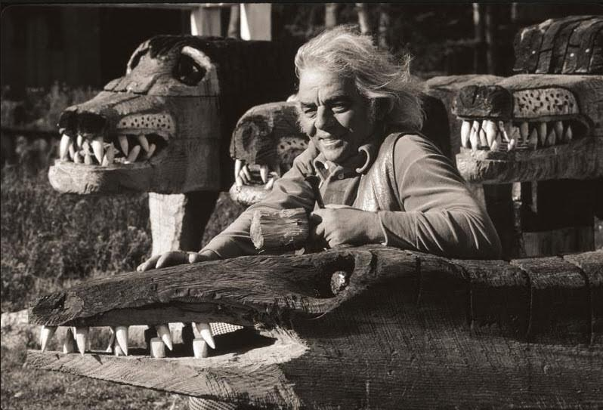
Bernard Langlais: A Discussion of Maine's Native Son
At the
Old Town Museum
A presentation of the artist's career and legacy in his home state and his collection at the Colby College Museum of Art
By Paige Doore, C.C.M.A.
Sunday, June 5, 2016
2:00 p.m.
